28 juin 2023 Test version 28 june 2023

Messages parametrable chua xong het.

Version chay kha hon. Nhung co nhieu chi tiet lat vat.

1 .

Anh chay thu 2 PNR chu aco trong DB, thi vo Altea OK.

Anh thay cach show message ko on de gay hoan mang.

The PNR could be not found,

Please wait moment …

Running batch ….

Minh nen chi co 1 message khi bat dau vao Altea : « We are loading your PNR from PSS … » den het process.

Message RED truoc khi vao Altea : … NOT FOUND

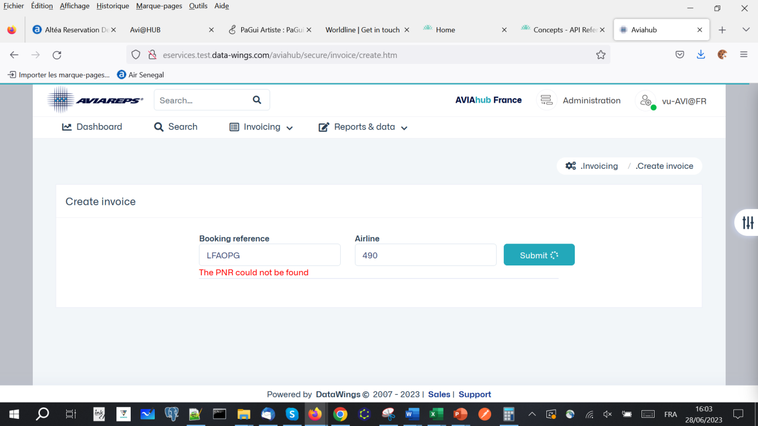

Search from Altea

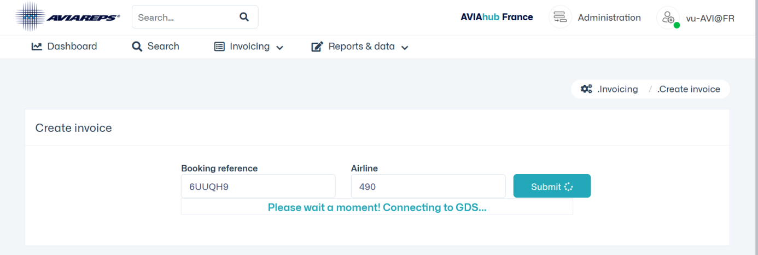 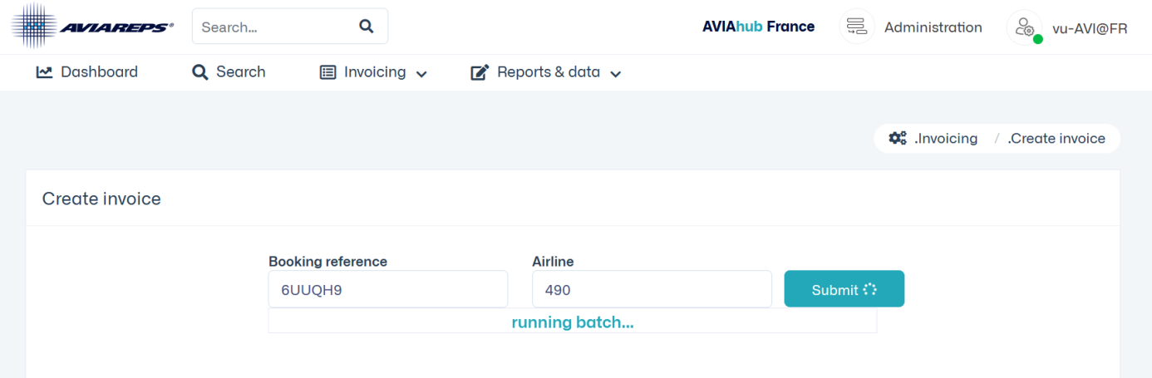

2. PNR : 490 2410507793 80.00 0.00 0.00 0.00 CA SOW/HORS PM 6UUQH9 TKTT

Xem lai loader vi Other tax -274 . Ve EX

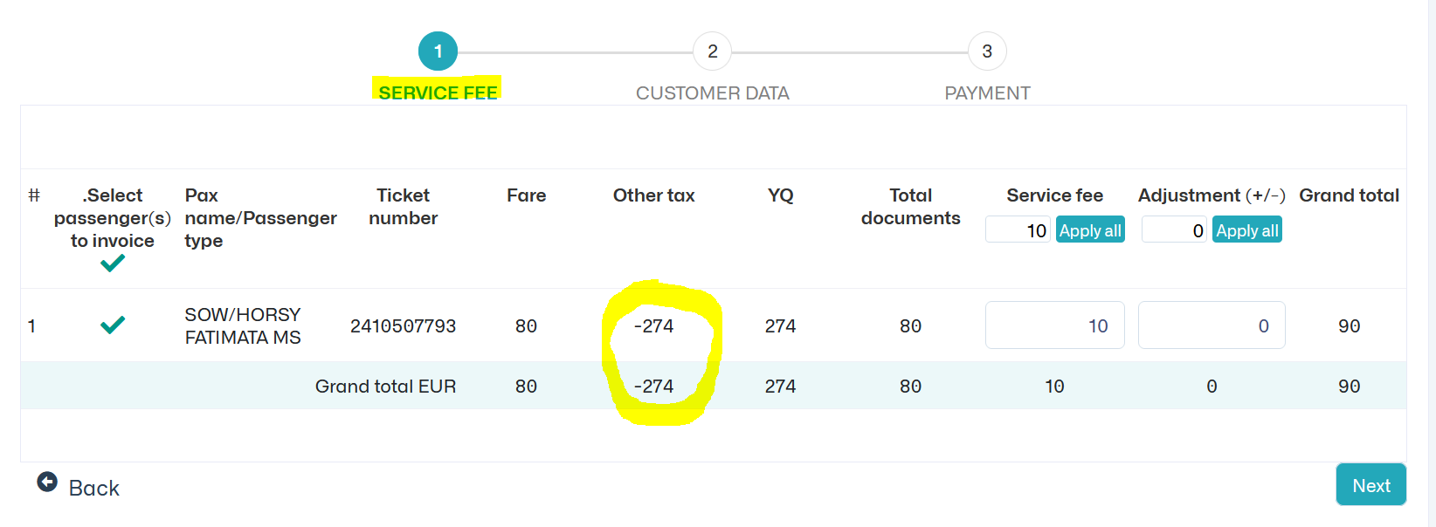

3. Sau khi send mail, Notification hoi STRANGE. Co cach chi khac ko

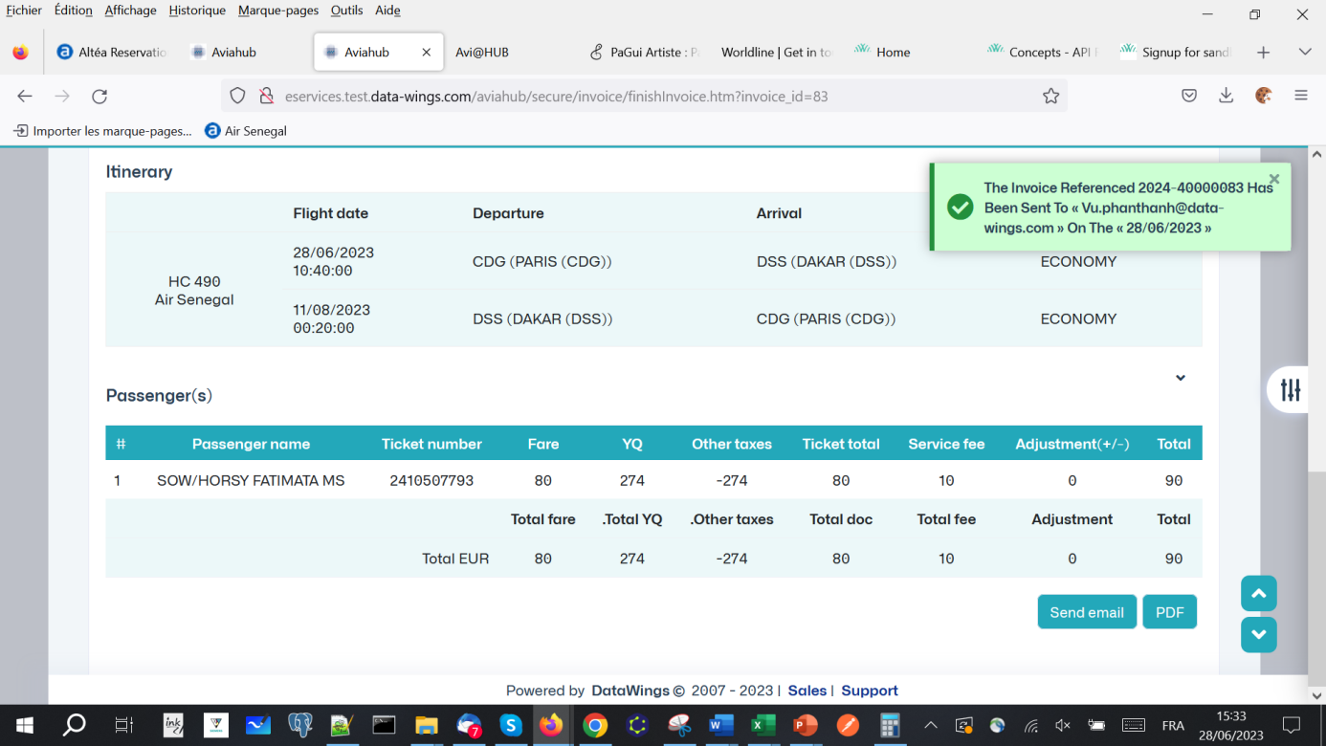

4. PNR 490 2410507794 456.29 260.29 0.00 0.00 CA CHABROL/ PM LFAOPG TKTT

Xem lai loader, chi co ve 490 2410507794 moi duo clam invoice. Ve 92…8162 ko invoice duoc vi OUTSIDE Aviareps

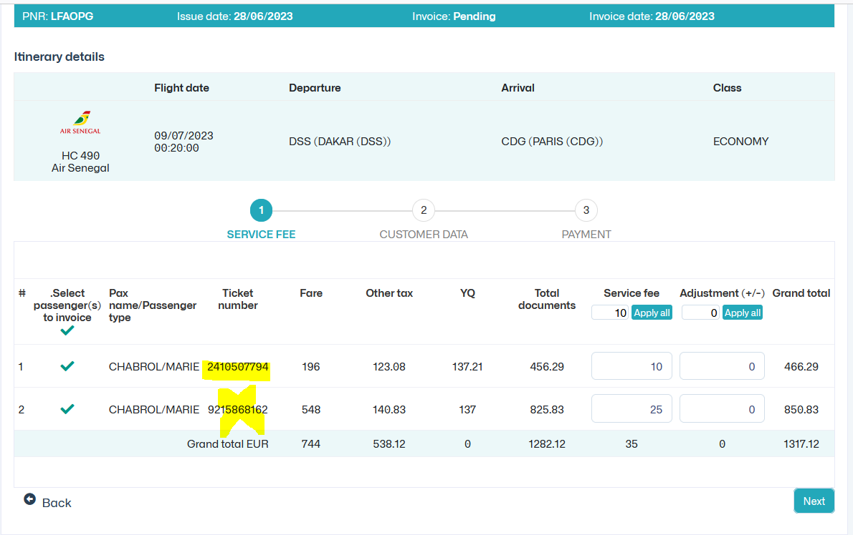

5. Step cuoi cung cua create / modify invoice se ve dau ? Them button BACK or Close de tr ove Search invoice

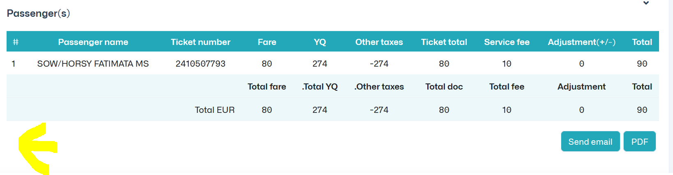

Xem lai content Customers from Document

Customers from Office la gi ?

Khi vo trang nay, Title, Fisrt Name Last name , email, phone ko thay auto complete

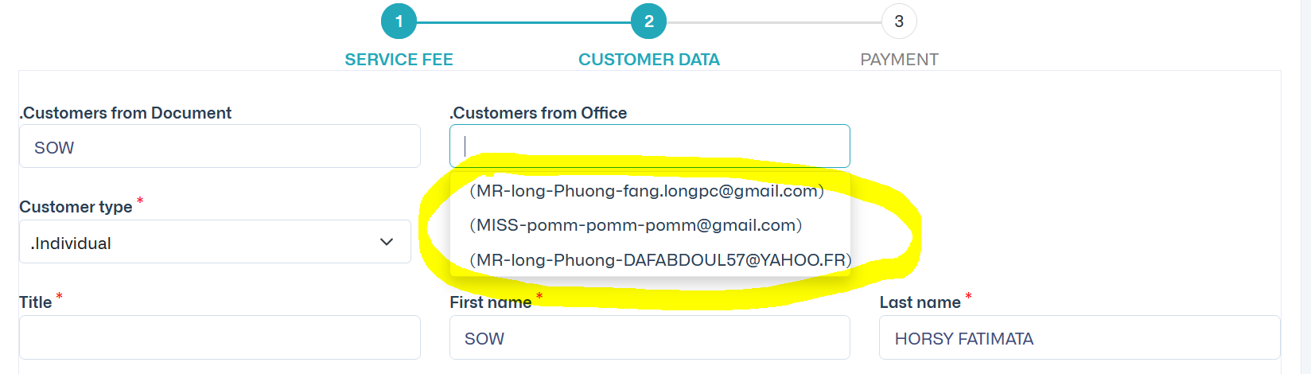

6. Xem lai format Amount co qua nhieu decimals.

Luon luon show co 2 decimals neu Currency loai nhu USD/EUR, co parameter decimal currency.

Vi du USD2, XOF0 , VND0

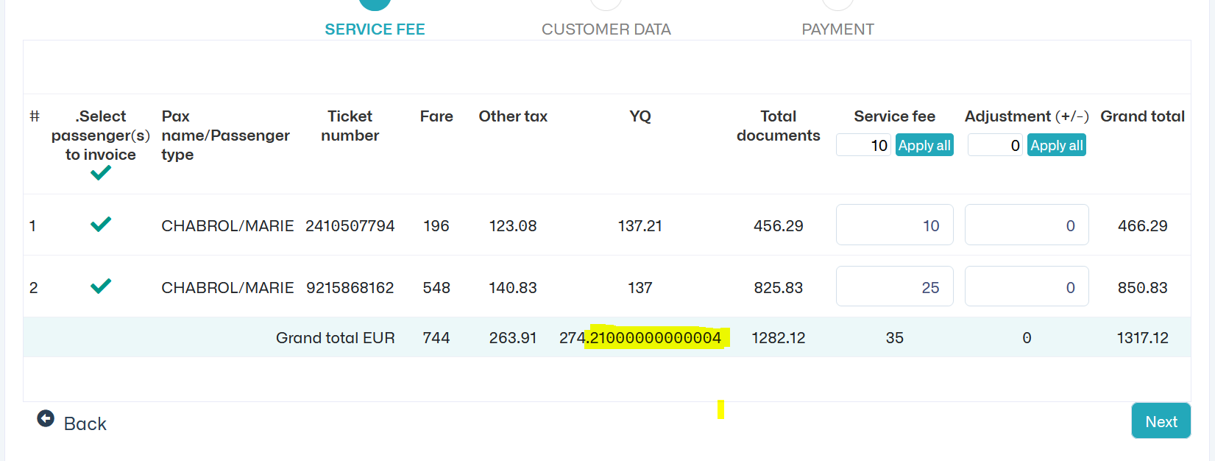

7. Quan ly lai message duoi sai GRAMMAR, va phai phan biet duoc invoice has been already invoiced va invoice is pending

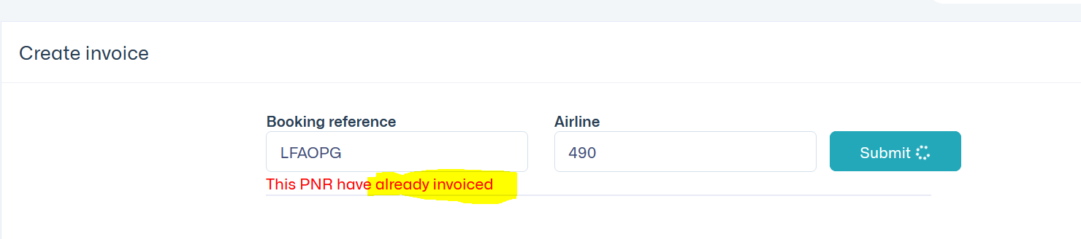

8. Format decimals amount

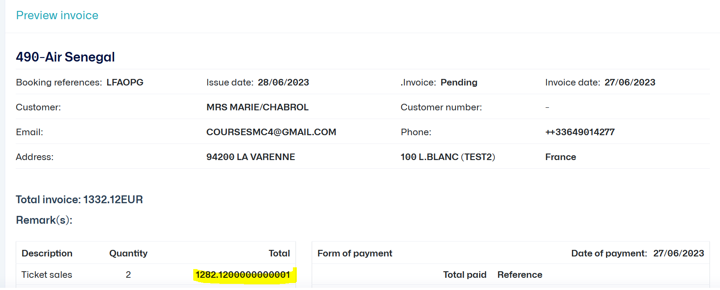

9. Truong hop duoi la bat on, create invoice mo o Tab moi, va menu Create invoice van click vao duoc nen Create duoc invoice.

Menu Create invoice ko thay active

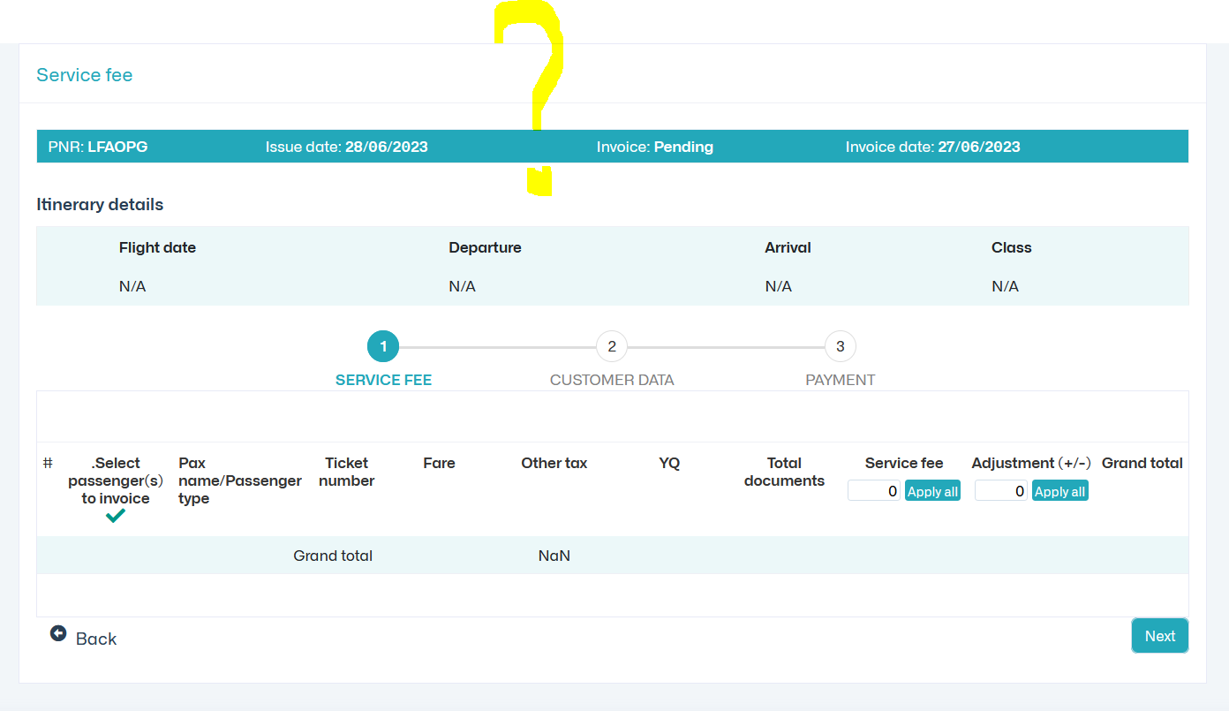

11. Trong cot Action, them Delete cho phep delete Invoice Pending. Trong ROLE phai co Option nay.

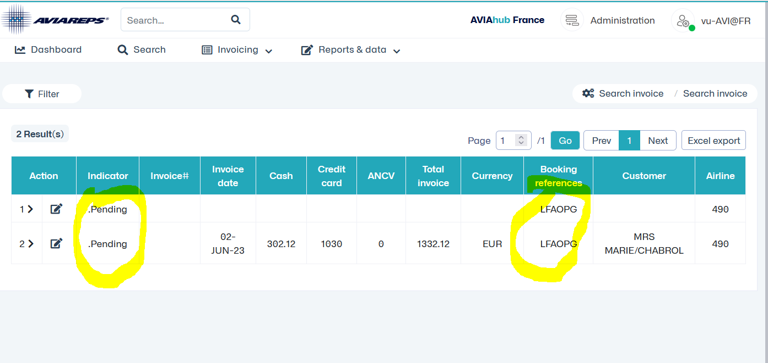

12. Align amounts

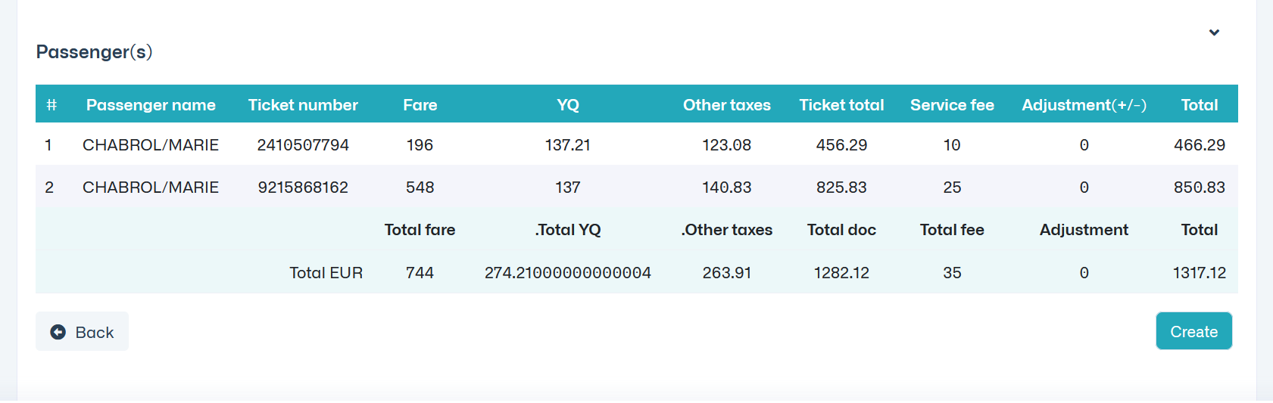

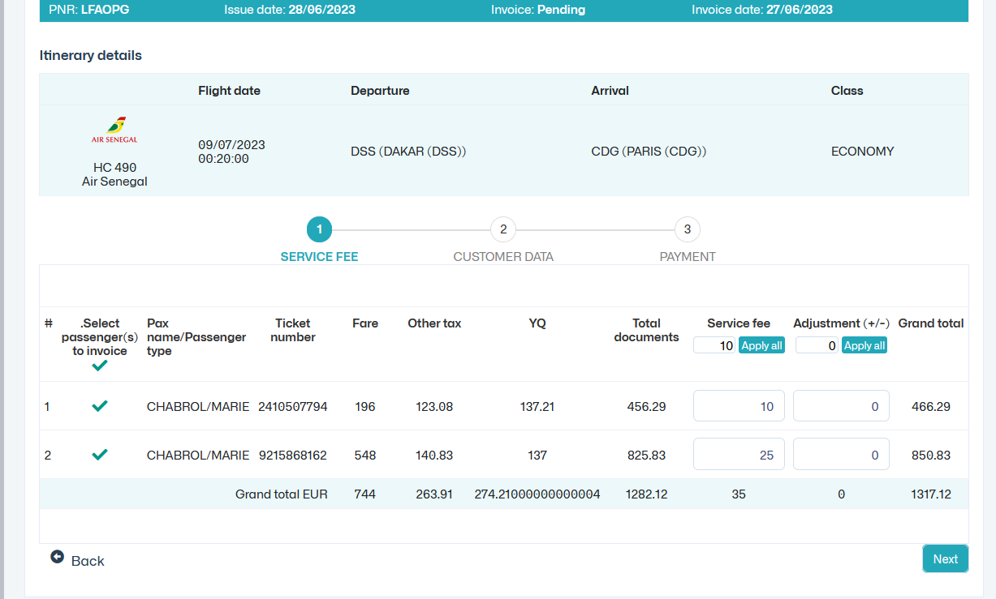

13. Bug NaN

Thieu validators o Credit Card.

